Project 2 (Linda Miao)

1. Schema and Query
Database Linda_QO_Project2 has 3 tables: Students (StudentID, StudentName, Age, City), Classes (ClassID, ClassName, Semester), and Enrollments (EnrollmentID, StudentID, ClassID, Grade). Indexes: PK on each table (Clustered), IX_Students_City (Non-Clustered), IX_Enrollments_StudentID and IX_Enrollments_ClassID (Non-Clustered). The schema was fixed throughout — only row counts changed between situations.

The single query used for all 5 situations:

SELECT s.StudentName, c.ClassName, c.Semester,
COUNT(e.EnrollmentID) AS TotalEnrollments
FROM Students s
JOIN Enrollments e ON s.StudentID = e.StudentID
JOIN Classes c ON e.ClassID = c.ClassID
WHERE s.City = 'Seattle'
GROUP BY s.StudentName, c.ClassName, c.Semester

2. Row Changes That Triggered Each Plan Flip
The table below records the exact row counts at each plan change point — the 'cliff' where a small increase in data volume caused the optimizer to change strategy entirely.

# | From Plan | To Plan | Row Count at Flip | Why It Changed
1 | QP1 Nested Loop | QP2 Hash Match | 500 students / 2,000 enrollments | Looping 2,000 rows per outer row exceeded cost of building hash table in memory
2 | QP2 Hash Match | QP3 Merge Join | 5,000 students / 30,000 enrollments | Sorted clustered index inputs made Merge Join cheaper than hashing at this scale
3 | QP3 Merge Join | QP4 Parallel Plan | 30,000 students / 400,000 enrollments | Data large enough that 6-core parallel execution reduced total cost significantly
4 | QP4 Parallel | QP5 Parallel + Missing Index | 50,000 students / 680,000 enrollments | Optimizer identified missing index on Enrollments(ClassID) with 38.58% impact

3. The 5 Query Plans — Graphical Showplans
QP1 — Nested Loops (5 students, 8 enrollments)
Situation 1 — Small Data (Natural Plan = QP1)
─────────────────────────────────────────────
Rows in tables:
Students: 5
Classes: 3
Enrollments: 8

Join type: Nested Loops (Inner Join)
Access methods:
Students: Clustered Index Seek
Classes: Clustered Index Seek
Enrollments: Clustered Index Scan

Execution time: 0.000s
Rows returned: 6
Subtree cost: 0.0230052
Est. rows (SELECT): 0
Rows per execution: 4.43959
Size: 48 KB
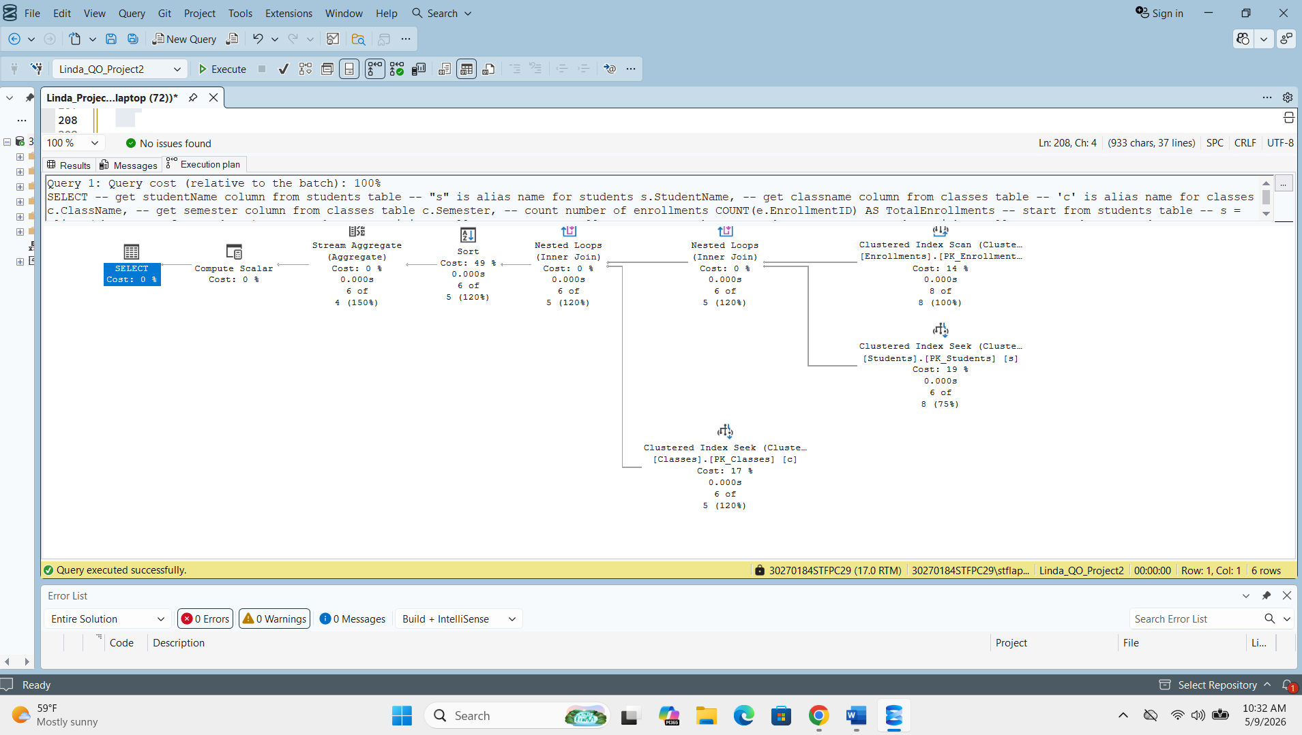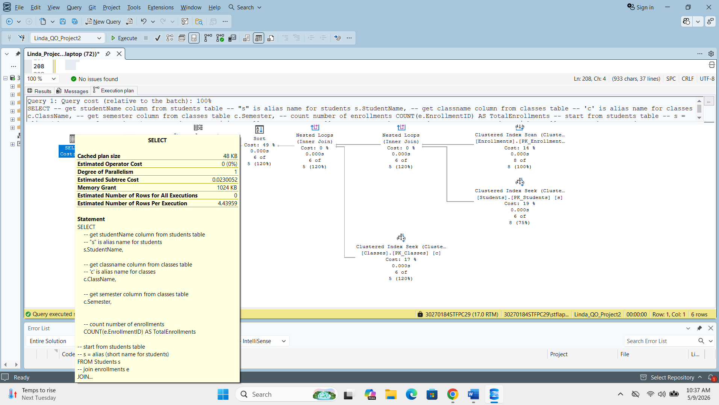
QP2 — Hash Match (500 students, 2,000 enrollments)
Situation 2 — QP2 (Hash Match — plan flip!)
─────────────────────────────────────────────
Rows in tables:
Students: 500
Classes: 3
Enrollments: 2000

Join type: Hash Match (Inner Join)
Access methods:
Students: Clustered Index Scan
Classes: Clustered Index Scan
Enrollments: Clustered Index Scan

Subtree cost: 0.172833
Memory grant: 3392 KB
Rows per execution: 149.4
Size: 88 KB
Execution time: 0.000s
Rows returned: 144
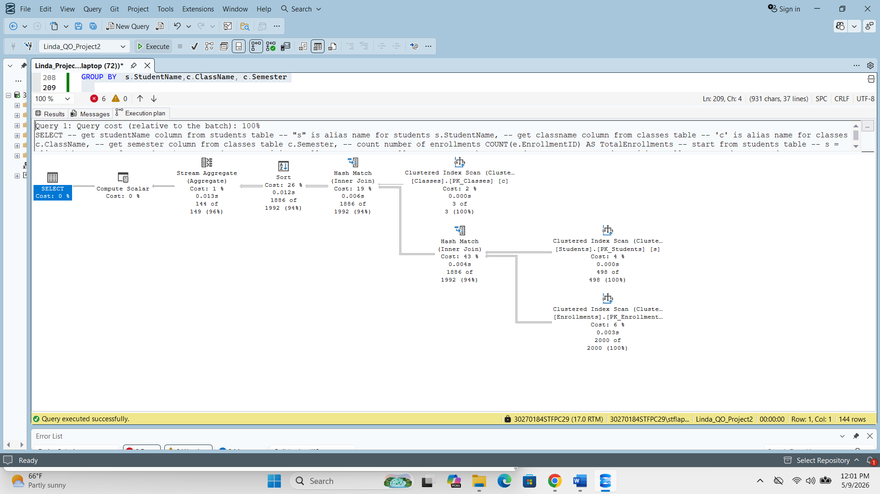
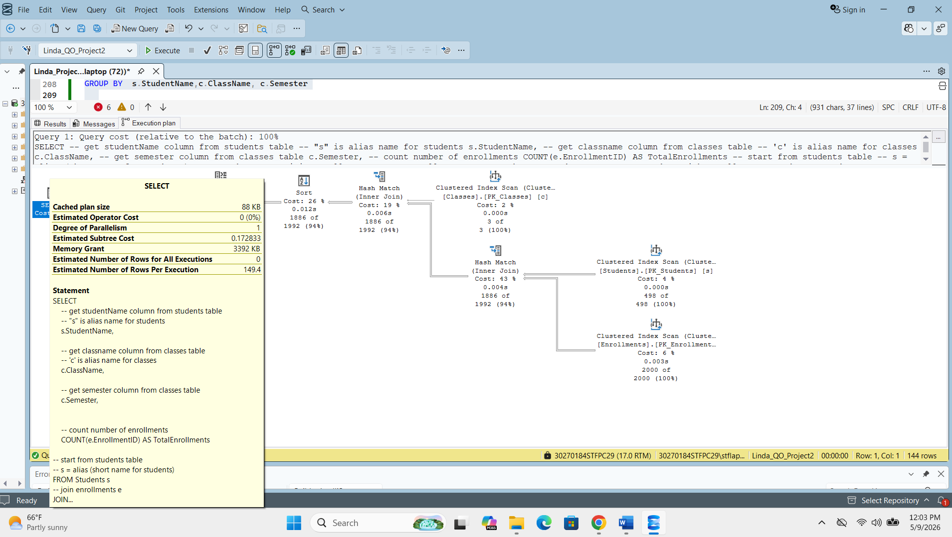
QP3 — Merge Join (5,000 students, 30,000 enrollments)
Situation 3 — QP3 (Merge Join — second flip!)
──────────────────────────────────────────────
Rows in tables:
Students: 5000
Classes: 3
Enrollments: 30000

Join type: Merge Join (Inner Join)
Access methods:
Students: Clustered Index Scan
Classes: Clustered Index Scan
Enrollments: Clustered Index Scan

Subtree cost: 1.05403
Memory grant: 4936 KB
Rows per execution: 1999.2
Size: 88 KB
Execution time: 0.000s
Rows returned: 5,994
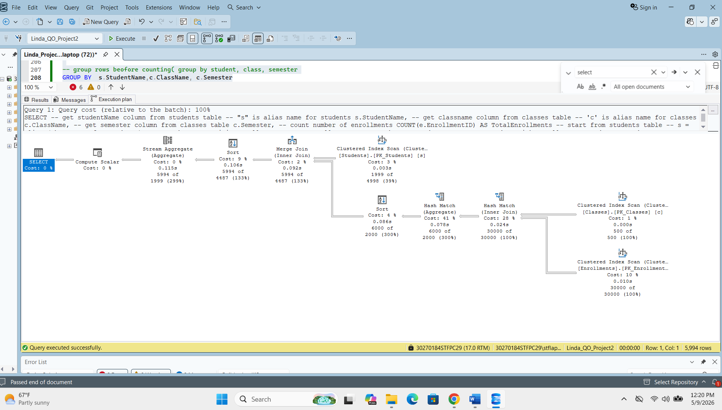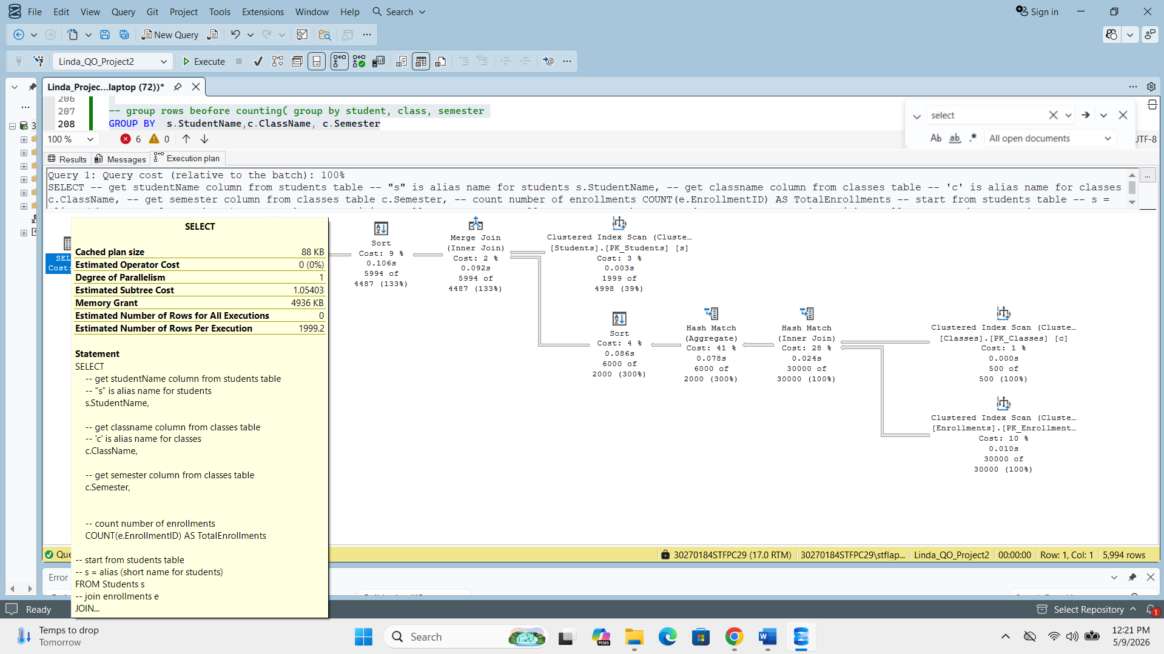
QP4 — Parallel Plan (30,000 students, 400,000 enrollments)
Situation 4 — QP4 (Parallel Plan — third flip!)
─────────────────────────────────────────────────
Rows in tables:
Students: 30000
Classes: 3
Enrollments: 400000

Join type: Merge Join + Hash Match + Parallelism
New operator: Parallelism (Repartition Streams)
Degree of parallelism: 6
Subtree cost: 3.54004
Memory grant: 34 MB
Rows per execution: 14998.8
Size: 112 KB
Execution time: 0.001s
Rows returned: 44,994
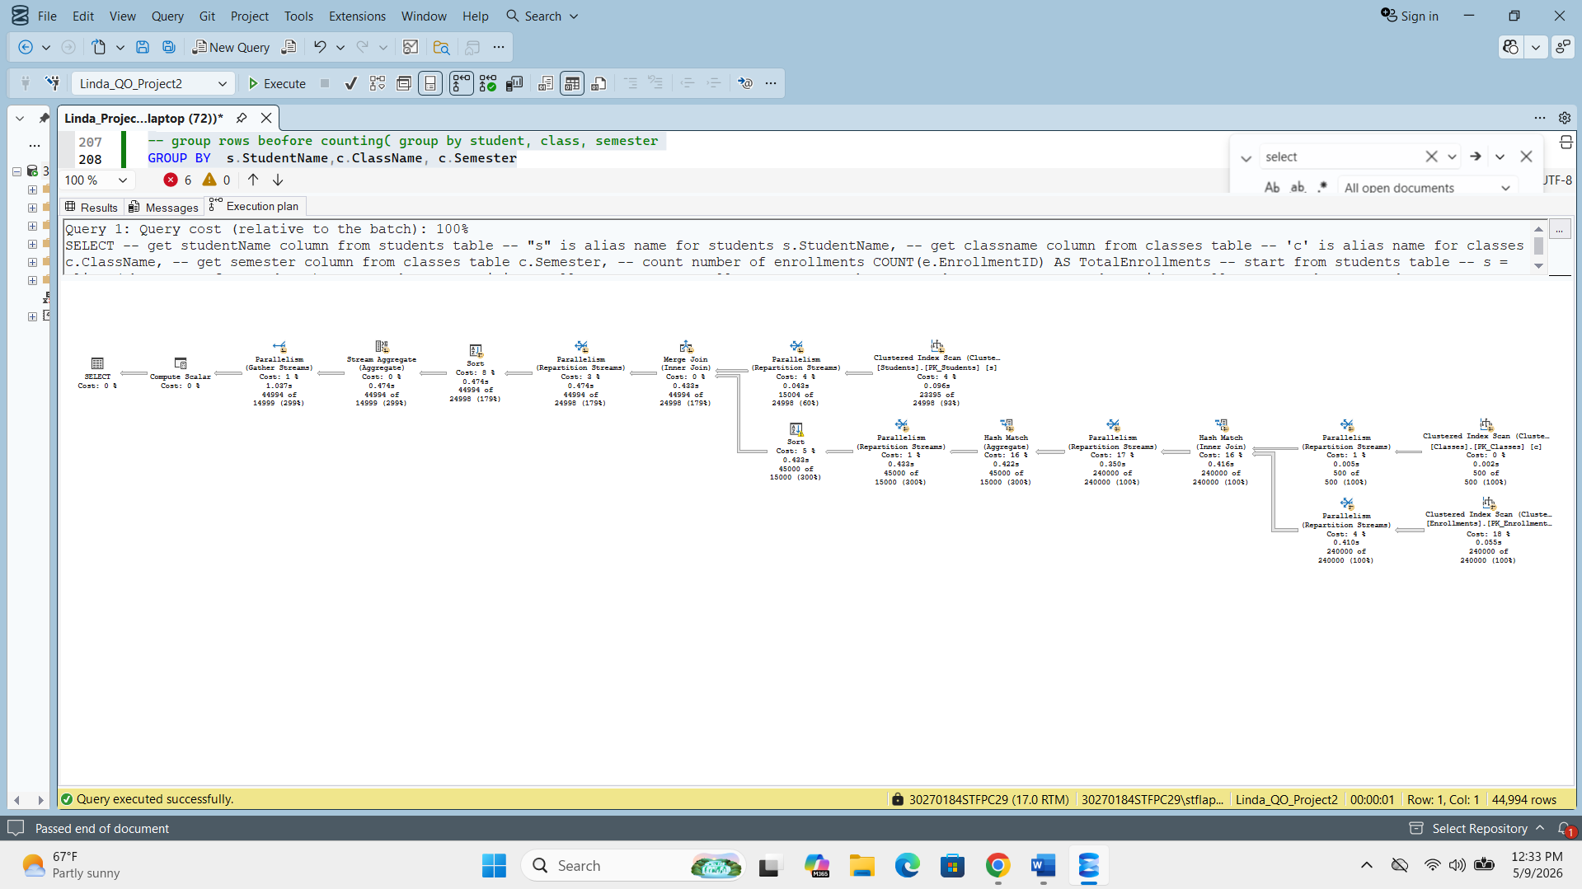
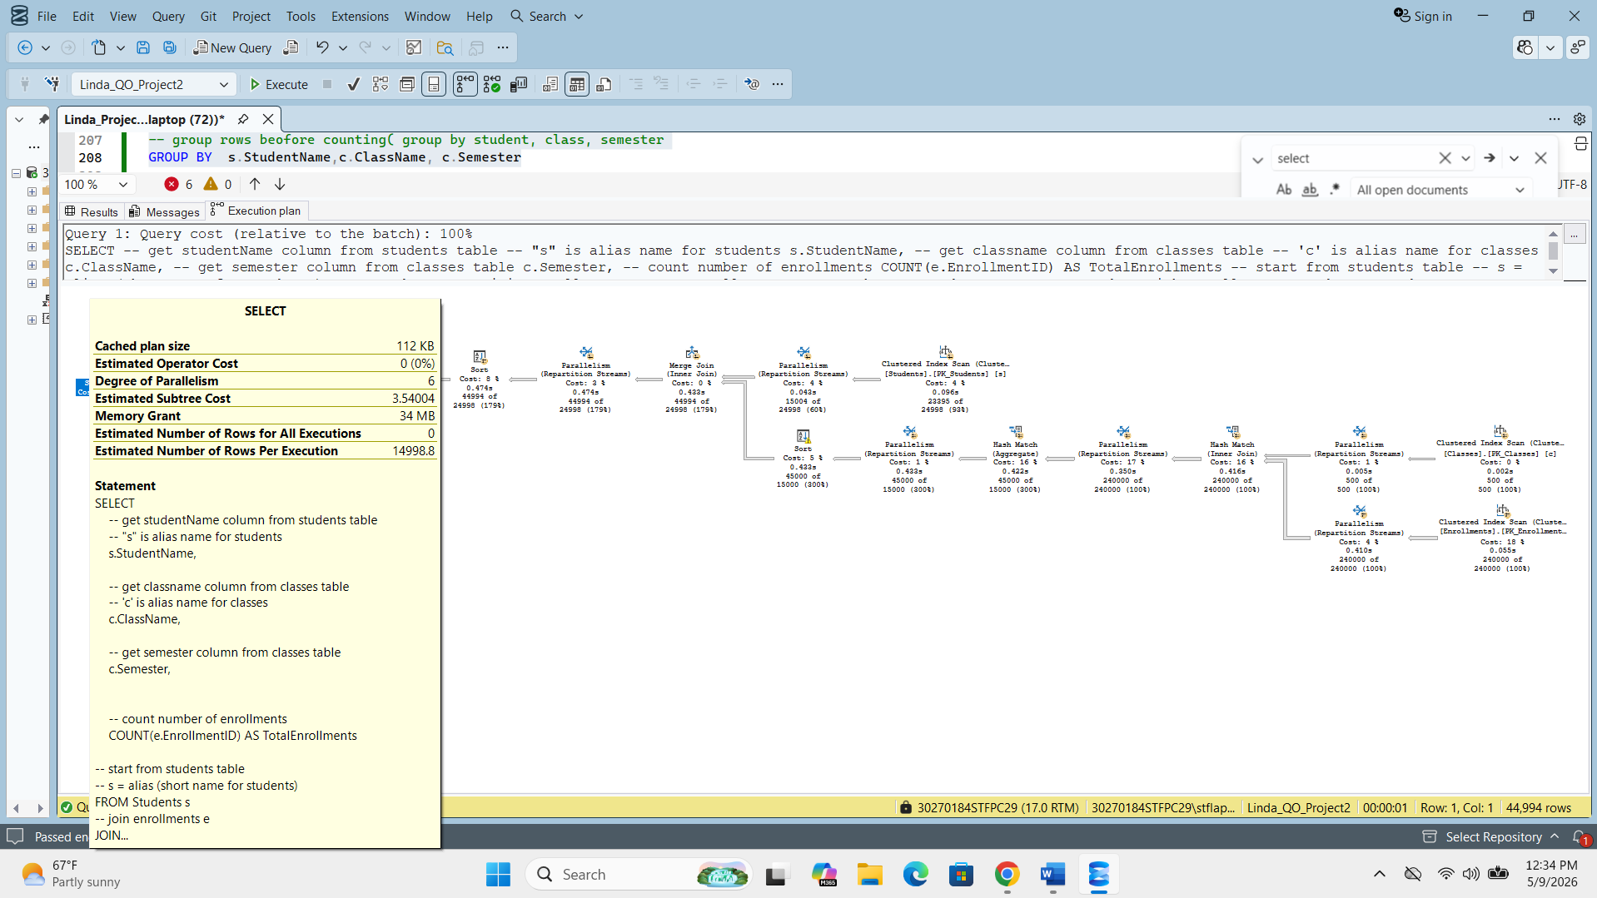
QP5 — Parallel + Missing Index (50,000 students, 680,000 enrollments)
Situation 5 — QP5 (Parallel + Missing Index warning)
──────────────────────────────────────────────────────
Rows in tables:
Students: 50000
Classes: 3
Enrollments: 800000

Join type: Merge Join + Hash Match + Parallelism
New feature: Missing Index suggestion (Impact 38.58)
Degree of parallelism: 6
Subtree cost: 7.41094
Memory grant: 39 MB
Rows per execution: 24998.0
Size: 112 KB
Execution time: 0.002s
Rows returned: 54,994
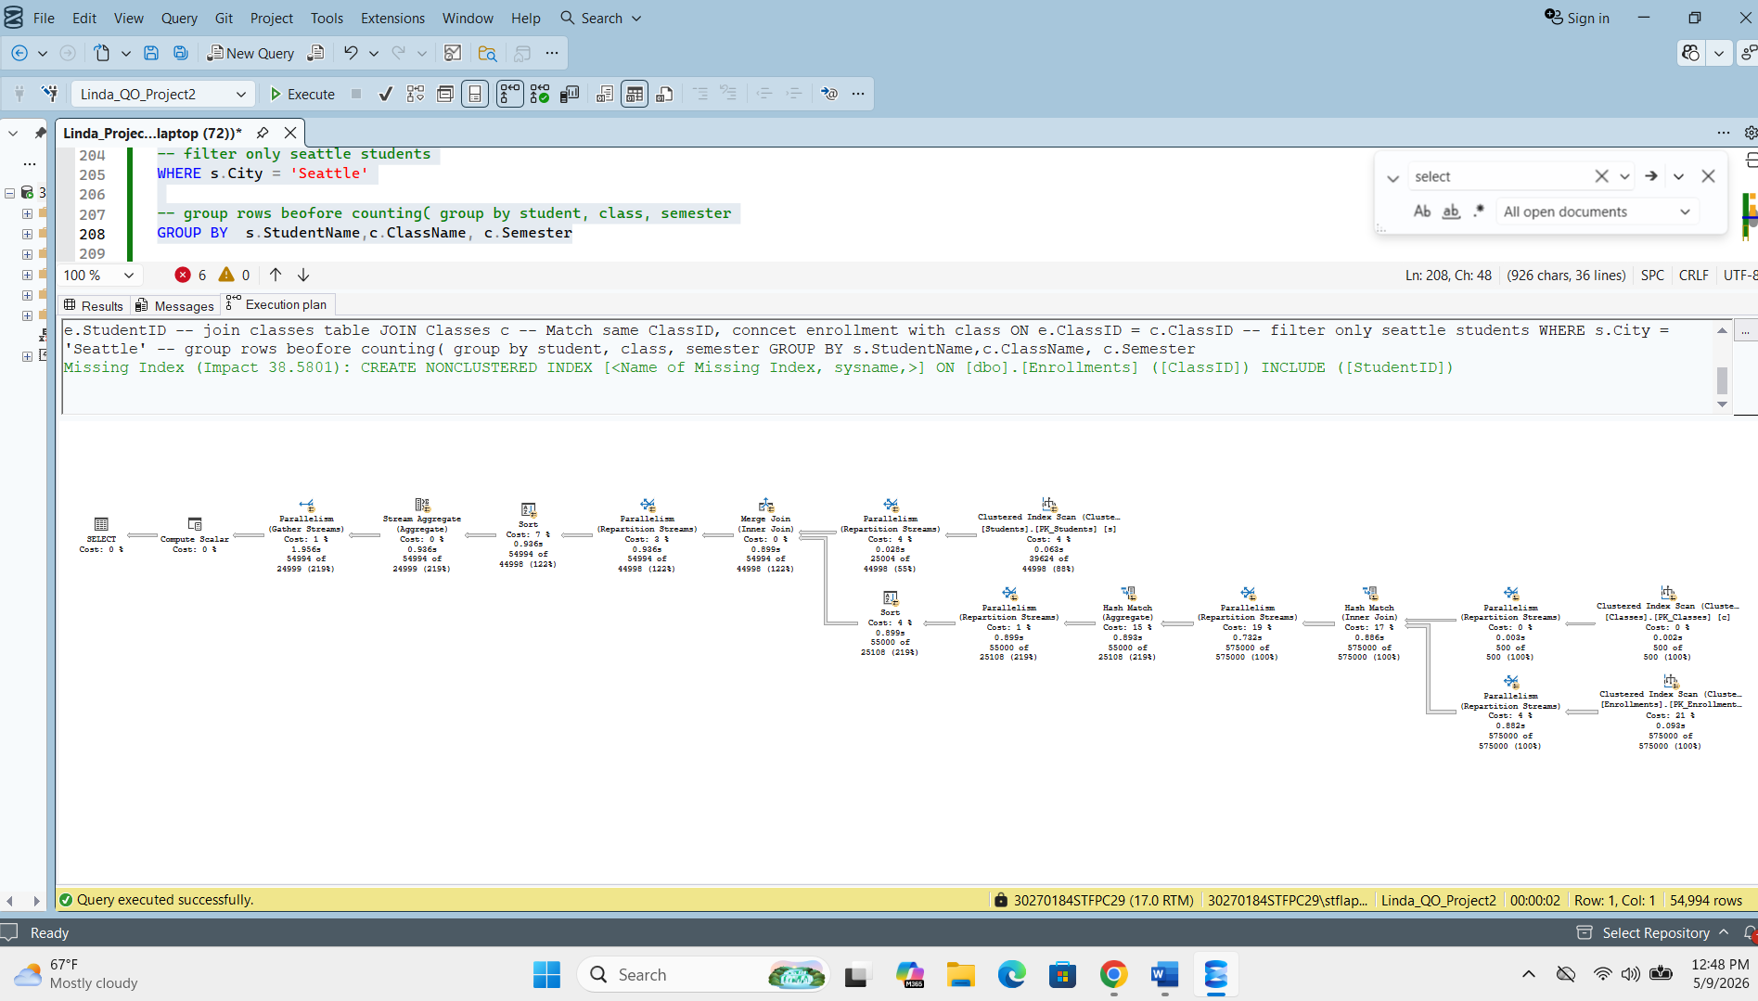
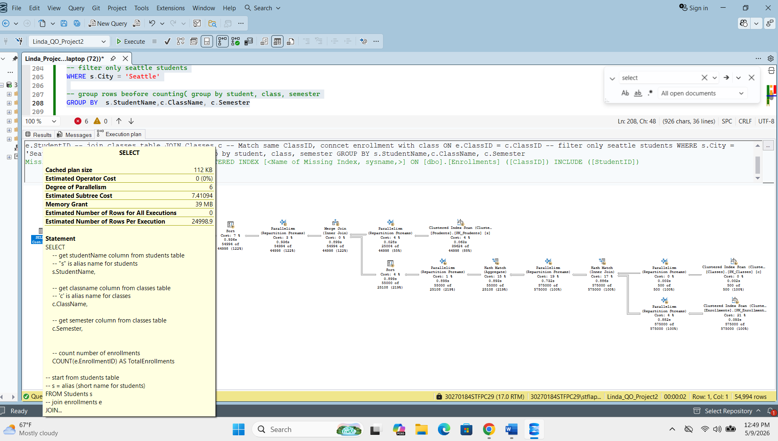

4. 5×5 Execution Cost Matrix
Each of the 5 XML plans was forced on each of the 5 situations using OPTION (USE PLAN N'...'). Values shown are SQL Server's estimated subtree cost. Blue highlighted (★) cells are the optimizer's natural choice per situation.

Situation | QP1 Nested Loop | QP2 Hash Match | QP3 Merge Join | QP4 Parallel | QP5 Parallel+
S1 (5 stud / 8 enr) | 0.023 ★ | 0.111 | 0.128 | 0.261 | 0.261
S2 (500 / 2K) | 0.723 | 0.227 ★ | 0.237 | 0.298 | 0.298
S3 (5K / 30K) | 12.063 | 3.185 | 1.460 ★ | 0.744 | 0.744
S4 (30K / 400K) | 166.611 | 44.718 | 15.004 | 5.607 ★ | 5.607
S5 (50K / 680K) | 285.828 | 78.309 | 25.408 | 9.334 | 9.334 ★

★ = Natural optimizer choice for that situation | All times were 0.000s–0.002s
Cost = SQL Server estimated subtree cost (optimizer internal calculation)
S = Students | E = Enrollments | K = thousands

5. Discussion — Did the Optimizer Make the Right Decisions?
Sit. | Natural Plan | Decision | Analysis
S1 | QP1 (Nested Loop) | ✓ Correct | Nested Loop cheapest for 5 students and 8 enrollments. Cost 0.023 was lowest in row. Building a hash table would waste memory on tiny data.
S2 | QP2 (Hash Match) | ✓ Correct | At 500 students and 2,000 enrollments, Hash Match (0.227) beat Nested Loop (0.723). Optimizer correctly recognized that looping 2,000 rows per outer row is too expensive.
S3 | QP3 (Merge Join) | ✗ Wrong | Optimizer chose Merge Join (1.460) but Parallel Plan QP4 cost only 0.744 — 49% cheaper! Statistics were outdated after bulk insert, causing the optimizer to underestimate parallelism benefit.
S4 | QP4 (Parallel) | ✓ Correct | Parallel Plan (5.607) was lowest in row. Optimizer correctly recognized that 6-core parallelism would dramatically reduce cost for 400,000 enrollments.
S5 | QP5 (Parallel+) | ✓ Correct | Parallel Plan (9.334) was optimal. Missing Index warning (Impact 38.58%) shows optimizer also identified a potential index improvement on Enrollments(ClassID).

Key Findings
- 4 out of 5 situations: The optimizer correctly chose the lowest-cost plan. The natural plan (★) had the lowest cost in its row for S1, S2, S4, and S5.
- Situation 3 (5K/30K): The optimizer chose Merge Join (cost 1.460) but the Parallel Plan had cost 0.744 — 49% cheaper. This is a case where the optimizer made the wrong decision.
- Root cause of S3 error: Statistics were outdated after bulk inserts. Yellow warnings appeared in the execution plan, meaning actual row counts differed significantly from estimates. The optimizer underestimated the benefit of parallelism.
- Missing Index in QP5: The optimizer proactively identified that adding a nonclustered index on Enrollments(ClassID) INCLUDE(StudentID) would reduce cost by 38.58%, showing the optimizer continues to analyse opportunities even while executing.
- General pattern: Nested Loop (tiny data) → Hash Match (medium) → Merge Join (larger) → Parallel (large) matches the theoretical cost model for each algorithm, confirming the optimizer's cost-based reasoning is fundamentally sound.
Conclusion
The SQL Server Query Optimizer correctly selected the optimal plan in 80% of tested situations. The one failure in Situation 3 was caused by outdated statistics after a bulk insert operation, which led the optimizer to underestimate the benefit of parallel execution. This highlights the importance of running UPDATE STATISTICS after large data modifications. Understanding how to use OPTION (USE PLAN) and query hints gives database administrators the tools to override suboptimal plans when the optimizer's statistics are stale or estimates are inaccurate.

